## HW18

## Wenhui Yang

## 4/27/2019

reg<-lm(apples$user_rating~apples$sizeMB+apples$price+apples$sup_devices.num

+apples$ipadSc_urls.num+apples$lang.num)

## call coefficient

reg.coef <- coef(reg)

reg.coef

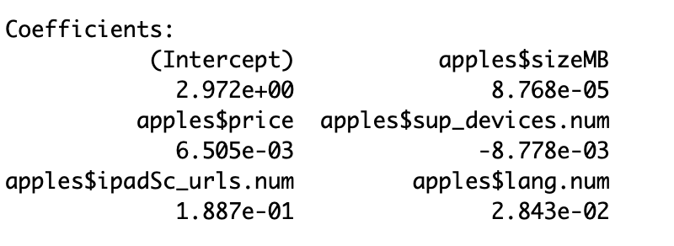

## call fitted values

reg.fit <- fitted(reg)

reg.fit

plot(reg.fit,apples$user_rating,main="Actual vs Fitted",

xlab = "Fitted value", ylab = "Actual value")

